**Map Tour Content: Amelia Earhart’s 1937 Flight**

**1st Location:**

**Media: Earhart’s plane**

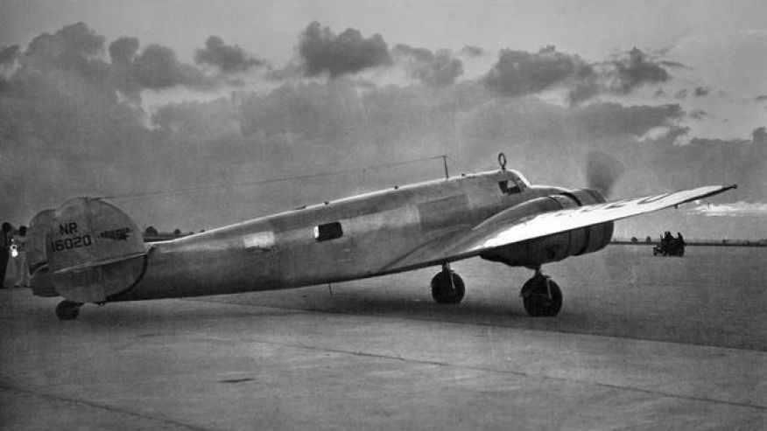

**Information:**

**Name:** June 1 - Miami to San Juan, Puerto Rico

**Caption:** Amelia Earhart flew a Lockheed Model 10E Electra, NR16020. As described in *The Evening Star* on June 1, 1937, "Miss Earhart planned to cruise the 1,033 miles to San Juan at a leisurely 150 miles an hour to test her plane further, and said she would return to Miami if anything went amiss." Photo Credit: *Miami Herald* via *This Day in Aviation*.

**Latitude:** 18.427755

**Longitude:** -66.1208951

__________________________________________________________________

**2nd Location:**

**Media:** Earhart in Caripito, Venezuela

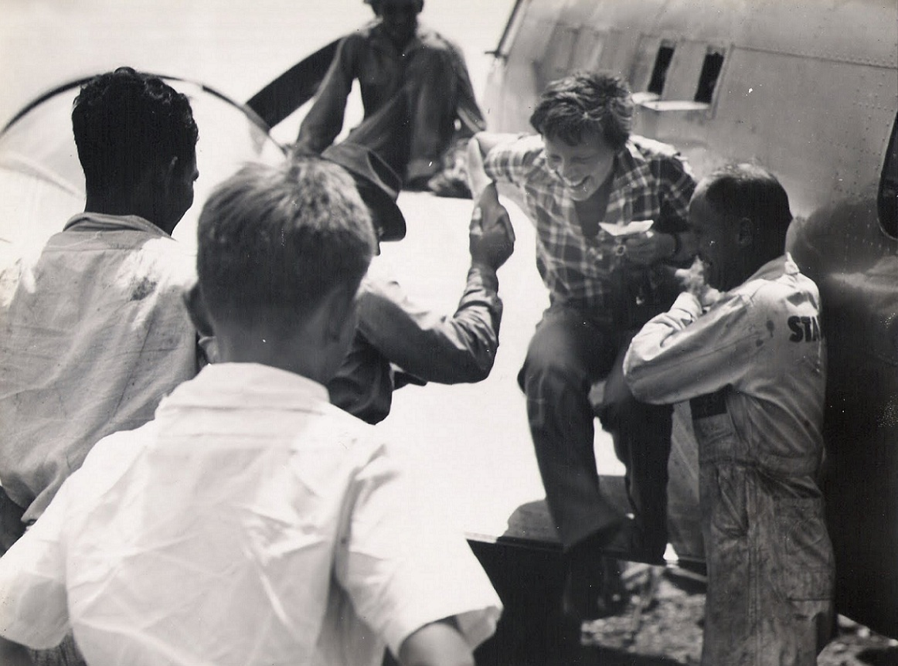

**Name:** June 2 - landed in Caripito, Venezuela

**Caption:** "The coast of Venezuela in the hazy distance was my first glimpse of South America. As we drew near I saw densely wooded mountains with wide valleys in between, open plain and jungle. I had never seen a jungle before." Amelia Earhart by wireless to *The Evening Star*, June 3, 1937. Photo credit: Earhart arriving in Caripito, via *This Day in Aviation.*

**Latitude:** 10.4120455

**Longitude:** -62.9454757

__________________________________________________________________

**3rd Location:**

**Media:** Earhart in Paramaribo, Suriname

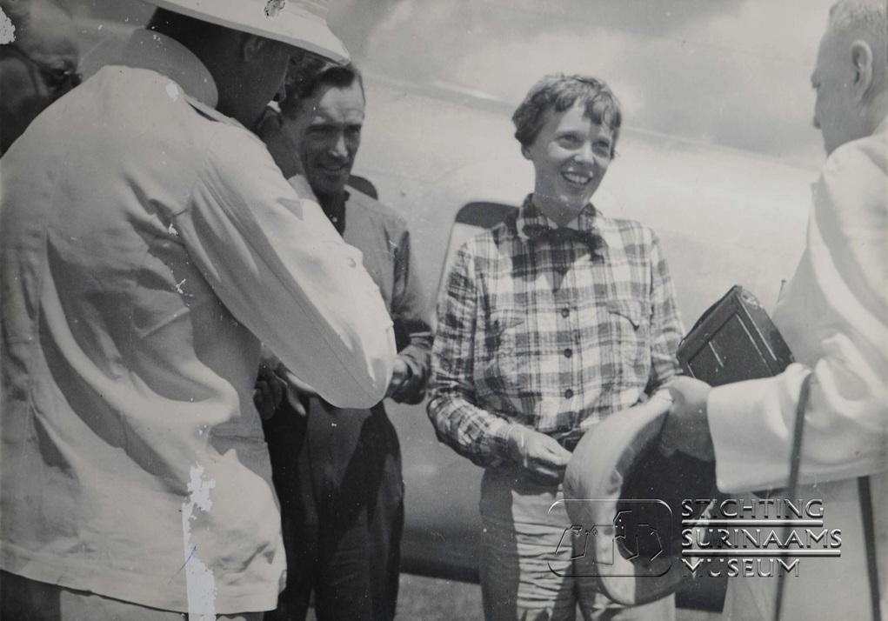

**Name:** June 4, landed in Paramaribo, Suriname

**Caption:** From Earhart's dispatch: "The weather at Paramaribo was perfect yesterday morning except for a morning mist from the Surinam River, when we took off, to skim the tree tops and then pull up." From Amelia Earhart's dispatch by wire to *The Evening Star*, June 5, 1937. Photo credit: Stichting Surinaams Museum

**Latitude:** 5.8484912

**Longitude:** -55.2478873

__________________________________________________________________

**4th Location:**

**Media:** Fortaleza, Brazil

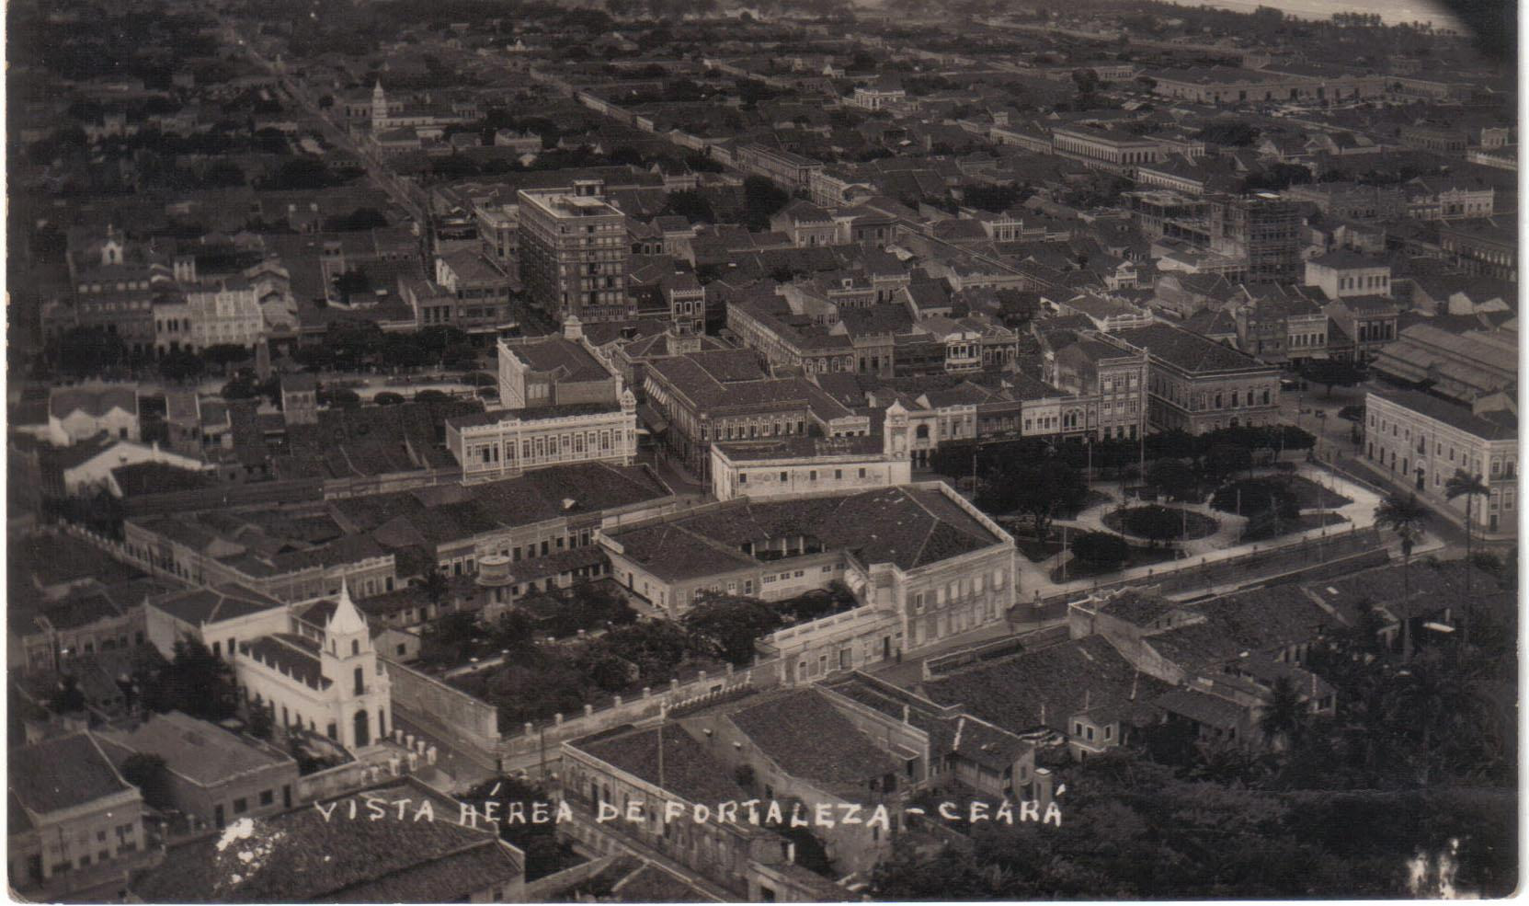

**Name:** June 5, landed in Fortaleza, Brazil

**Caption:** Earhart traveled from Fortaleza, Brazil to Natal, Brazil. Earhart writes "I was glad to see Fortaleza sitting just where it should be, according to the maps, between the mountains and the sea, a beautiful spot." Photo: Fortaleza, Brazil in 1936; uncredited.

**Latitude:** -5.7997439

**Longitude:** -35.2922846

__________________________________________________________________

**5th Location:**

**Media:** Saint-Louis, Senegal

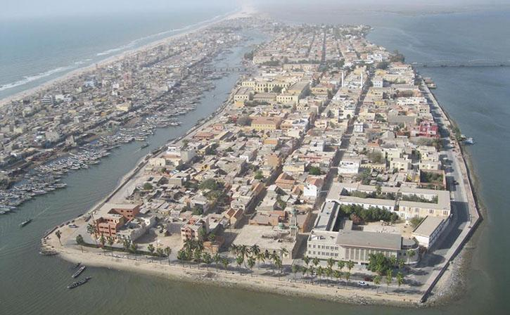

**Name:** June 7 - left Natal, Brazil for St. Louis, Senegal

**Caption:** "...I really had intended to land at Dakar, 163 miles south of St. Louis. The fault is entirely mine. When we first sighted the African coast thick haze prevailed. My navigator, Capt. Fred Noonan, indicated that we should turn south. Had we done so a few minutes would have brought us to Dakar. But a 'left turn' seemed to me more attractive, and 50 miles of flying along the coast brought us here." - Amelia Earhart's dispatch by wire, June 8, 1937. Published in *The Evening Star*. Photo: Saint Louis, Senegal, in 20th century.

**Latitude:** 16.0200352

**Longitude:** -16.4933188

__________________________________________________________________

**6th Location:**

**Media:** Earhart’s plane being serviced in Dakar, Senegal.

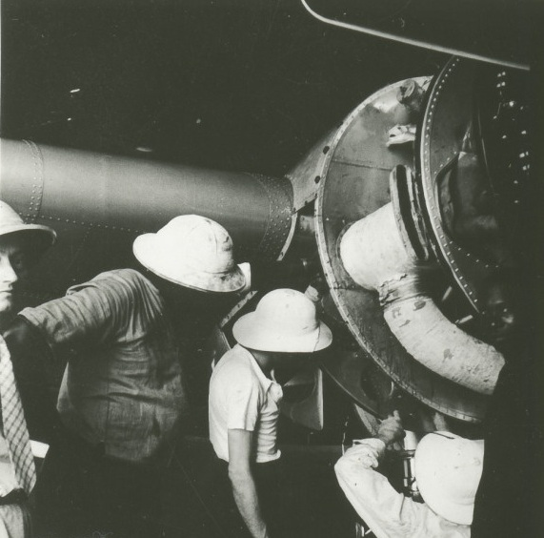

**Name:** June 8, arrived Dakar, Senegal

**Caption:** "The Dakar Airport is excellent, picturesquely situated on a jutting point of land, with the pink city nearby. Before starting eastward overland I had a periodic check made of the faithful plane and engines. Equipment which serves so well deserves good care." -Amelia Earhart dispatch by wire, published in *The Evening Star* June 10, 1937. Photo: Earhart having her plane serviced in Dakar, Senegal. From Purdue University Libraries, Archives and Special Collections via *Women in Aerospace History*.

**Latitude:** 14.71118

**Longitude:** -17.5358655

__________________________________________________________________

**7th Location:**

**Media:** N’Djamena, Chad airport

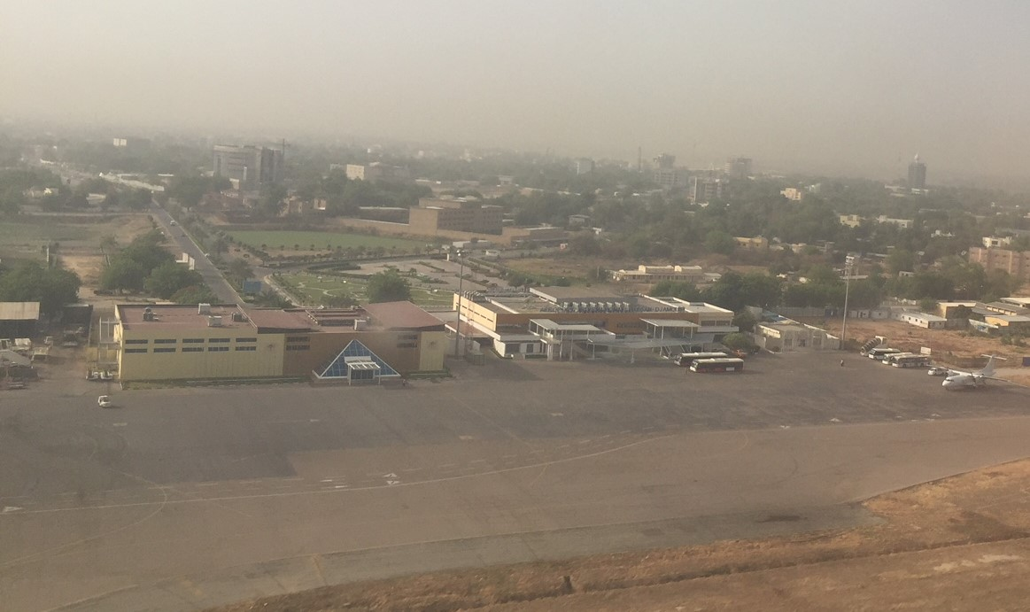

**Name:** June 11 - landed in N'Djamena, Chad

**Caption:** "Amelia Earhart started today on another leg of her round-the-world flight, lifting her monoplane easily into the eastern sky and heading for Fort Lamy, about 1,000 miles away, in the Lake Chad country of French Equatorial Africa." - Associated Press, June 11, 1937. Photo: Photo of N'Djamena, Chad airport in 20th century.

**Latitude:** 14.9874185

**Longitude:** 12.1203773

__________________________________________________________________

**8th Location:**

**Media:** Earhart’s Lockheed Electra plane in Khartoum, Sudan

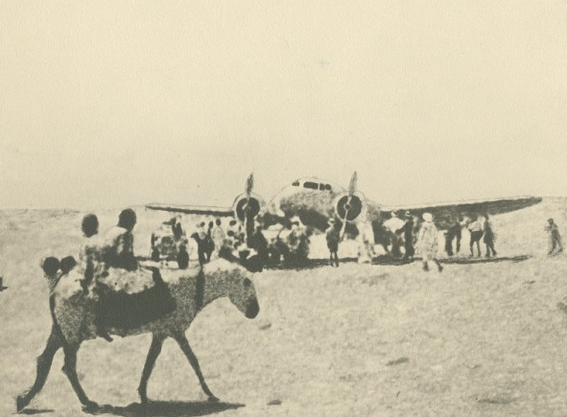

**Name:** June 13 - flew to Khartoum, Sudan from El Fasher, Sudan

**Caption:** "Yesterday we crossed another great river of the world. For us the Nile is a cheering landmark in the equatorial air voyage, as was the Amazon some days ago, each a geographical milestone on our way."" Amelia Earhart, published in *The Evening Star*, June 14, 1937. Photo: Amelia Earhart’s Lockheed Electra surrounded by onlookers. From Purdue University Libraries, Archives and Special Collections via *Women in Aerospace History*.

**Latitude:** 15.5016995

**Longitude:** 32.502556